Order Of Service

Singing: Psalm 30—CW page 76

Reading: Psalm 119:73-80

Opening Hymn: TLH 629

Reading: James 5:1-19

Request Hymn: CW Supplement 774

Reading: Luke 11:37-44

Sermon Hymn: TLH 243

Sermon Text: Acts 18:22-28

Apollos

Prayer

The Apostles’ Creed, TLH page 12

Holy Communion

The Lord's Prayer

The Blessing

Closing Hymn: TLH 248

************

Bible Study: Lambs: Tiger
Sheep: Deut. 19:11-21
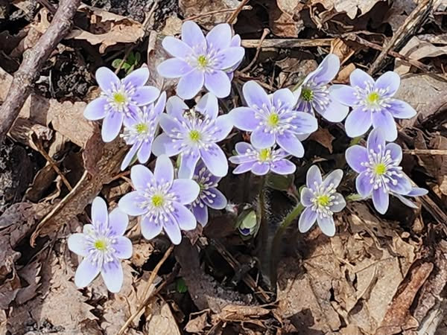

More May Flowers

Water
Of
Life

11 May 2025

W A T E R O F L I F E

Independent Christian Church—Conservative Lutheran Doctrine

Worship Service: 9:30 a.m.

Larry Cooper, Pastor E-Mail address:
lcooper@wateroflife.cc
Web Site:
www.wateroflife.cc

* * * * * * * * * * * * * * * * * * * * * * * * * * *

Sermon Text: Acts 18:22-28

Apollos

* * * * * * * * * * * * * * * * * * * * * * * * * * *

22 And when he had landed at Caesarea, and gone up, and saluted the church, he went down to Antioch.

23 And after he had spent some time there, he departed, and went over all the country of Galatia and Phrygia in order, strengthening all the disciples.

24 And a certain Jew named Apollos, born at Alexandria, an eloquent man, and mighty in the scriptures, came to Ephesus.

25 This man was instructed in the way of the Lord; and being fervent in the spirit, he spake and taught diligently the things of the Lord, knowing only the baptism of John.

26 And he began to speak boldly in the synagogue: whom when Aquila and Priscilla had heard, they took him unto them, and expounded unto him the way of God more perfectly.

27 And when he was disposed to pass into Achaia, the brethren wrote, exhorting the disciples to receive him: who, when he was come, helped them much which had believed through grace:

28 For he mightily convinced the Jews, and that publickly, shewing by the scriptures that Jesus was Christ.

